What is an Object?
- In Salesforce, an Object is like a database table used to store data specific to a business or organization.
- Each object contains records (rows) and fields (columns).

Types of Objects in Salesforce
Salesforce provides two types of objects:
Standard Objects
- These are pre-defined objects provided by Salesforce.
- Used for common CRM functionalities.
- They cannot be deleted, but they can be customized.
Examples: Account, Contact, Lead, Opportunity, Case
Custom Objects
- These are user-created objects based on business requirements.
- Used to store application-specific data.
- They can be deleted or modified.
- Custom object API names end with __c
Examples: Branch__c, Customer__c, Policy__c, Claim__c, Patient__c, HiringManager__c

Default Fields in Custom Objects
When you create a custom object, Salesforce automatically adds these fields:
- Name → Unique identifier for the record
- Owner → User responsible for the record
- Created By → User who created the record
- Last Modified By → User who last updated the record

OBJECT ASSIGNMENT

It should have following tables to store data Bank, Branch, Account, Loan, Loan Detail and transaction.
We will create 6 Objects:
- Bank
- Branch
- Account
- Transaction
- Loan
- Loan Detail

Create Bank Object
Step 1: Setup Object Manager Click Create Custom Object

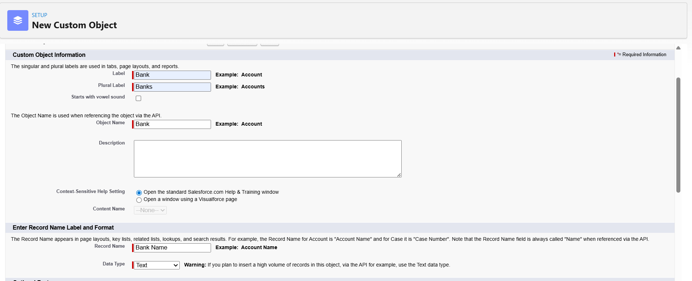

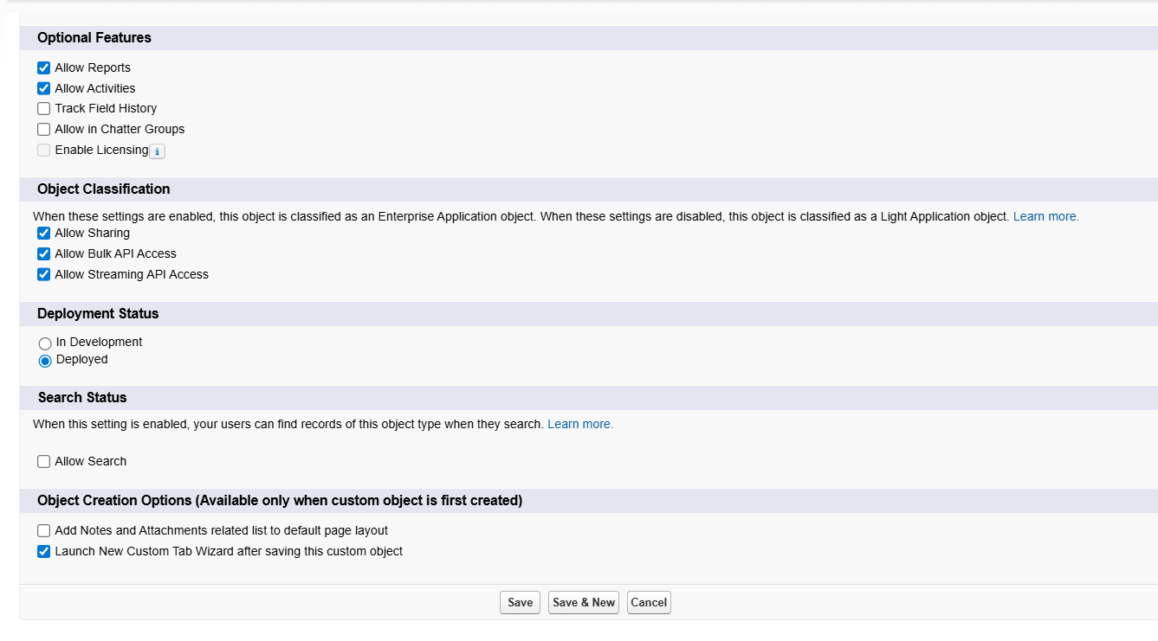

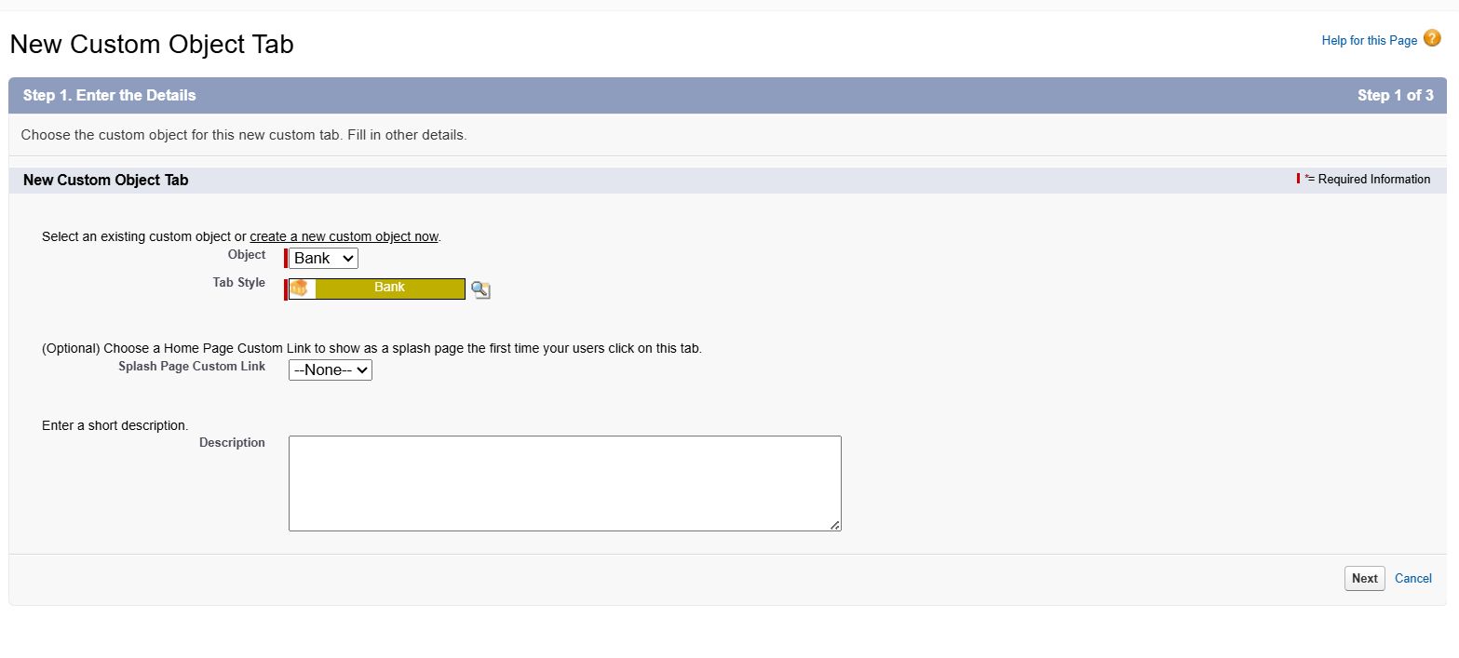

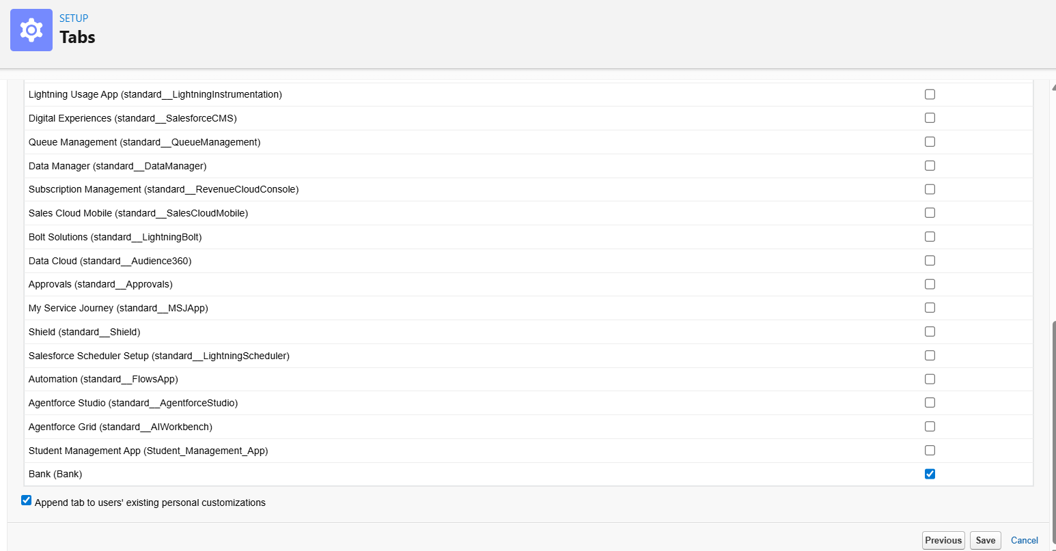

Create Branch Object

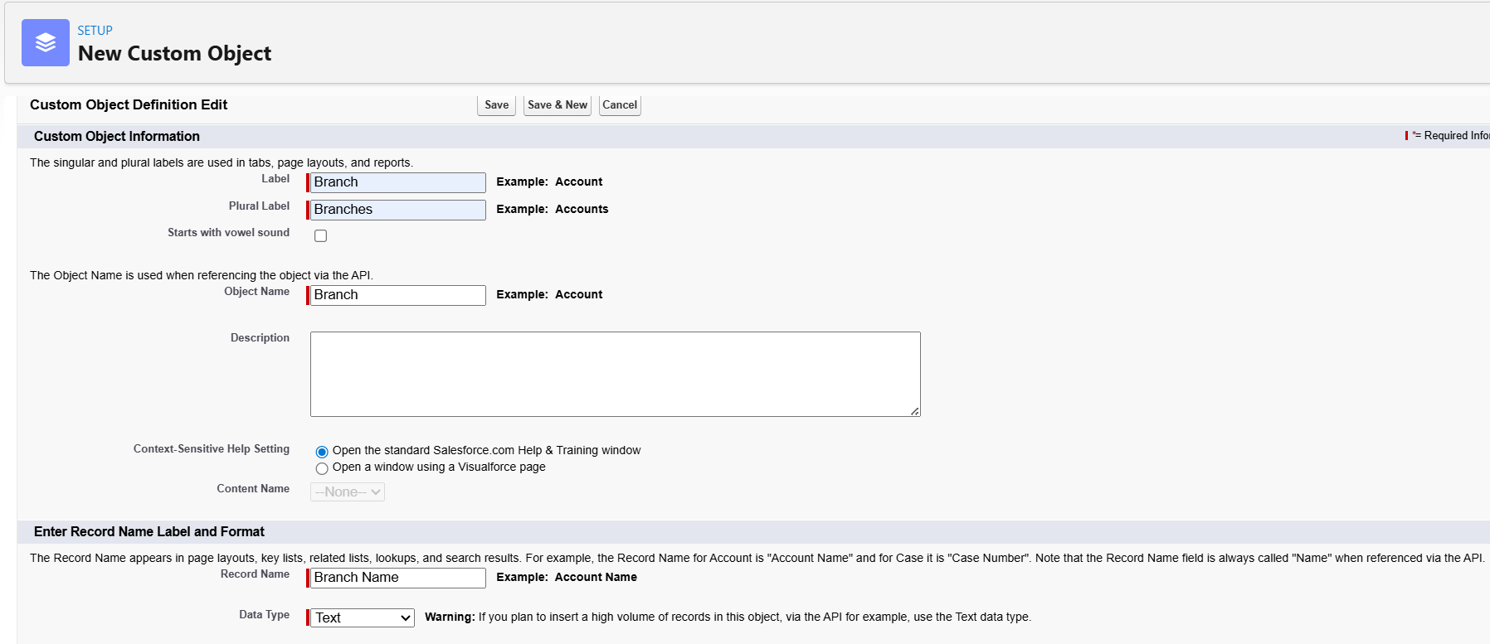

Create Bank Account Object
⚠️ Use name: Bank Account (to avoid confusion with standard Account)

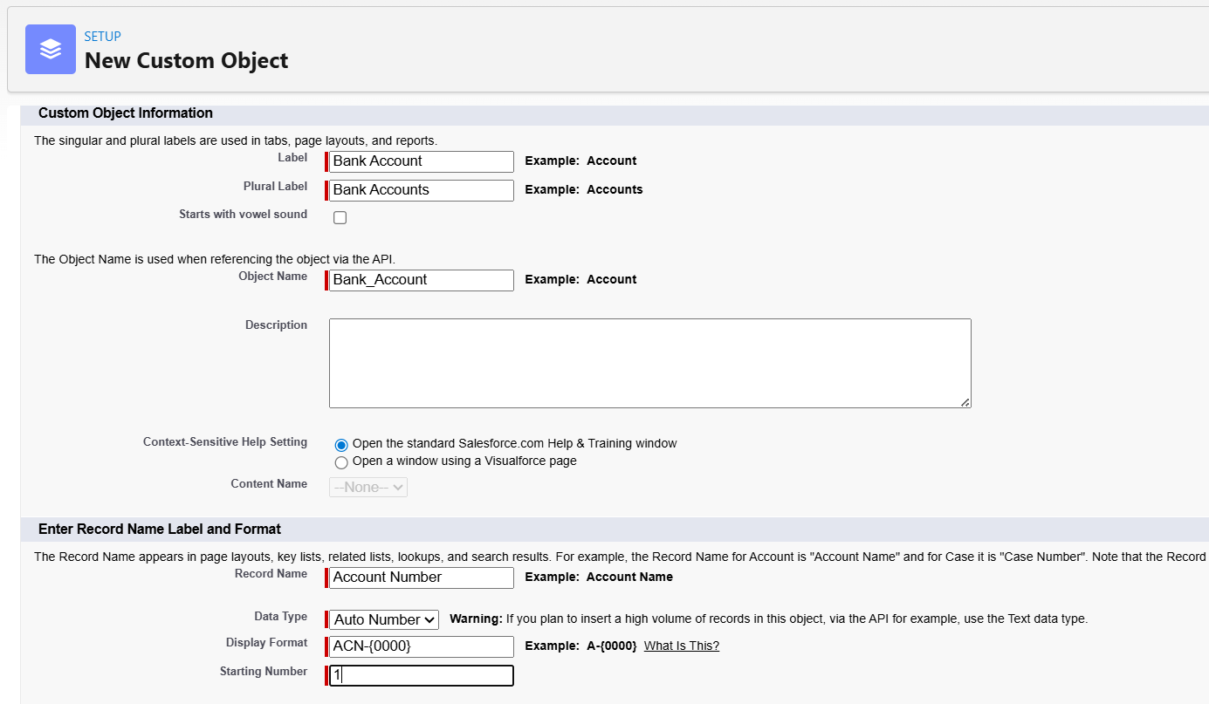

Create Transaction Object

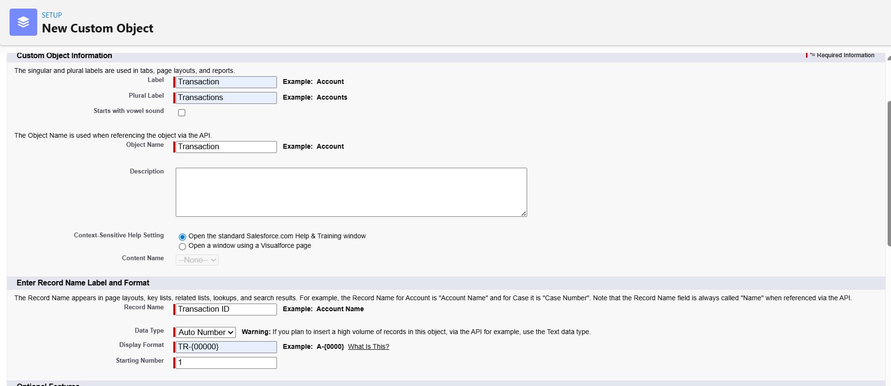

Create Loan Object

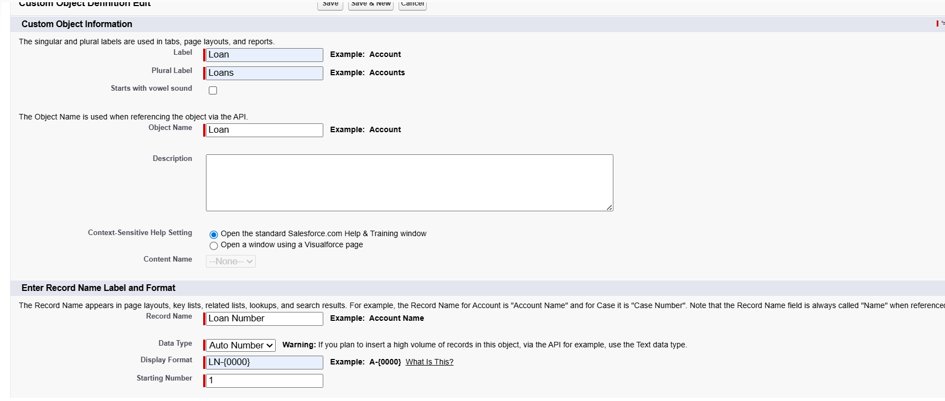

Create Loan Detail Object

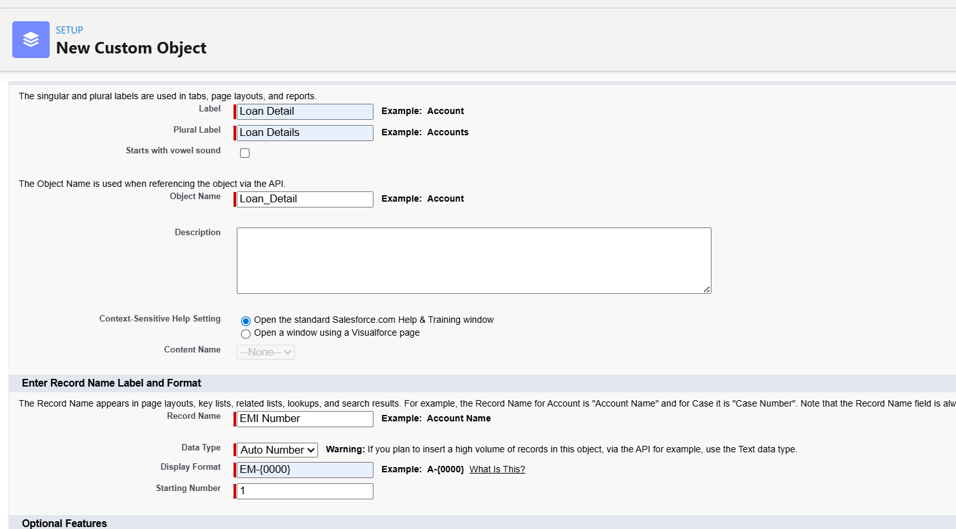

🎯 Why use Auto Number for Transaction, Loan, and Loan Detail?
I used Auto Number for Transaction, Loan, and Loan Detail objects to ensure unique, system-generated identifiers. Since these records are created frequently and require consistent tracking, auto-number eliminates manual errors, prevents duplicates, and mimics real-world banking systems where reference IDs are system-generated.

